|  |
| --- |
| Close-up image showing the leaf-sides of two oversized books side-by-side on a bookshelf, with additional books in soft focus background |
| User Manual Guide  **Brightcove video integration with Salesforce Commerce Cloud** |
| |  |  | | --- | --- | |  |  | |

Contents

User Manual Guide 3

Terms 4

Instructions: 5

1.1: How to add a video to the Brightcove server: 5

1.2 How to assign a video to a product in SFCC 12

1.3 How to embed a video in a content slot: 20

1.4 PDP Rendering: 25

1.5 Bulk-Upload: 27

Troubleshooting common issues 29

# User Manual Guide

This document provides step-by-step instructions for using Brightcove Salesforce Commerce Cloud Custom Cartridge to upload video files to the Brightcove Cloud/server and publish these files on product details page, as needed.



# Terms

|  |  |
| --- | --- |
| **Term** | **Description** |
| SFCC | Salesforce Commerce Cloud |
| Business Manager (BM) | The primary admin tool used to configure SFCC platform and customer facing storefront |

# Instructions:

Following sections describe details of instructions to add, assign, embed and bulk upload videos to the Brightcove cloud server using SFCC Business Manager.

## 1.1: How to add a video to the Brightcove server:

“Add Video” Module provides the functionality to add videos to the Brightcove Server/Cloud using SFCC Business Manager. Here are the steps:

1. Login to SFCC Business Manager with your valid credentials
2. Select Merchant Tools from the top-level BM menu and then navigate to the Brightcove section as shown below in the screenshot

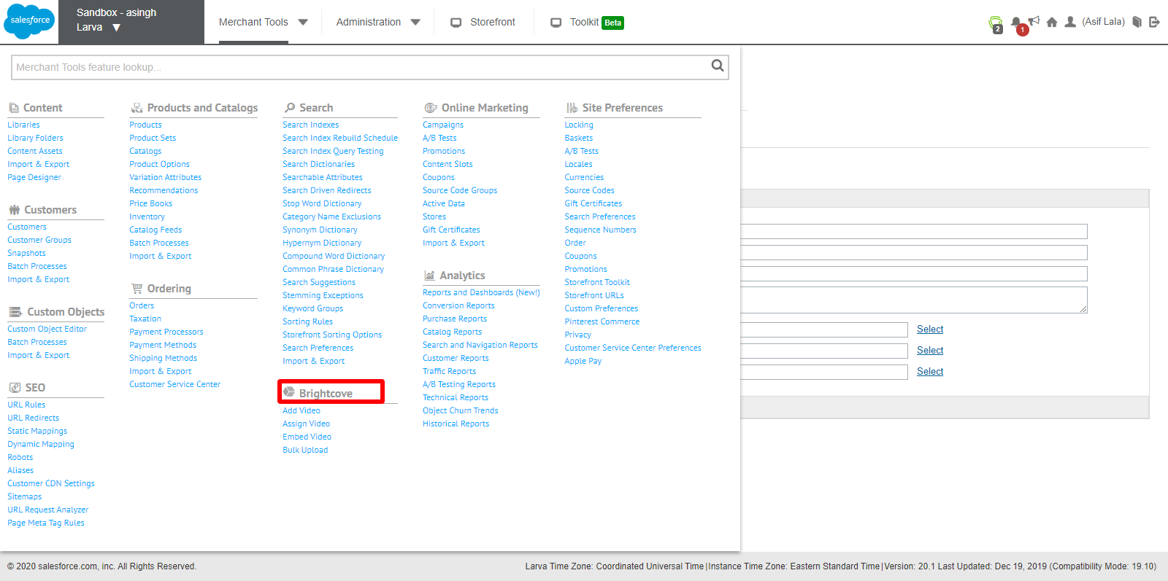

1. Under Brightcove section Select/Click “Add Video”

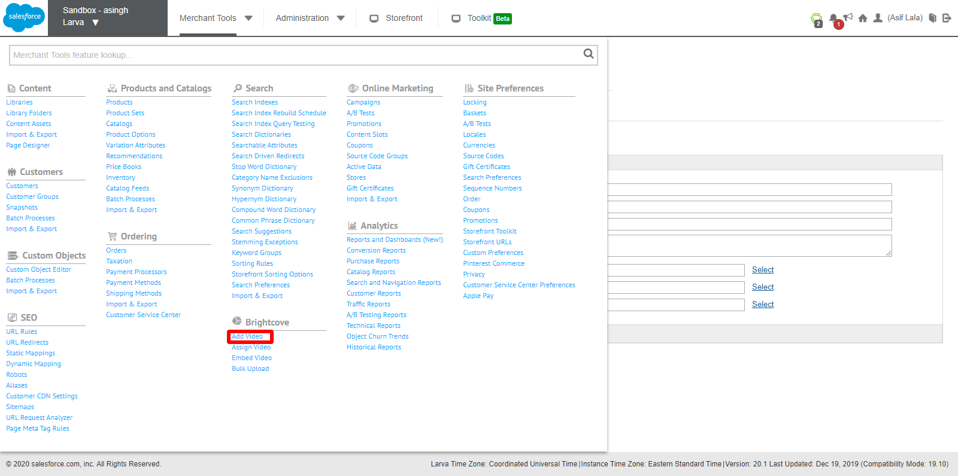

1. Add Video Page will be displayed. Fill out the form details to upload the video to Brightcove Server

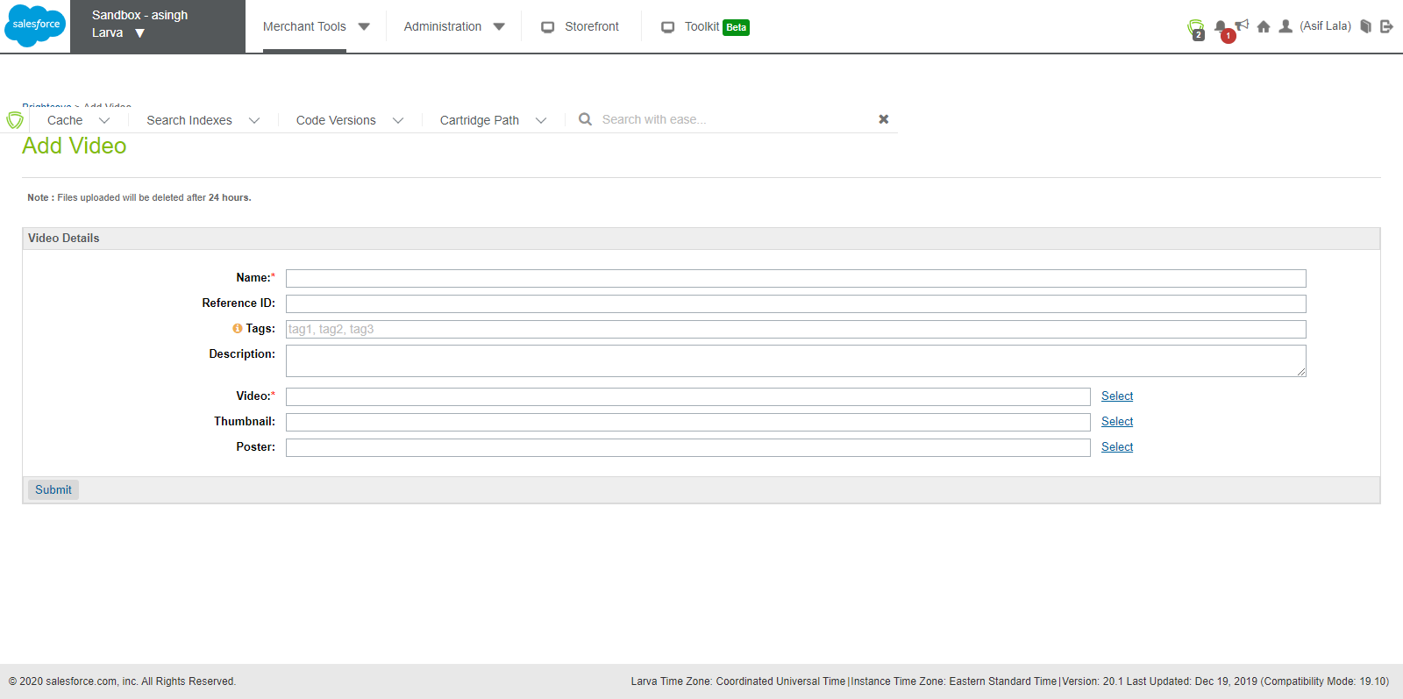

1. Make sure that appropriate information is entered in **Name** and **Video** fields (Mandatory fields).

Note: You can hover mouse over the tag field (the orange icon), for details on usage of the tag field.

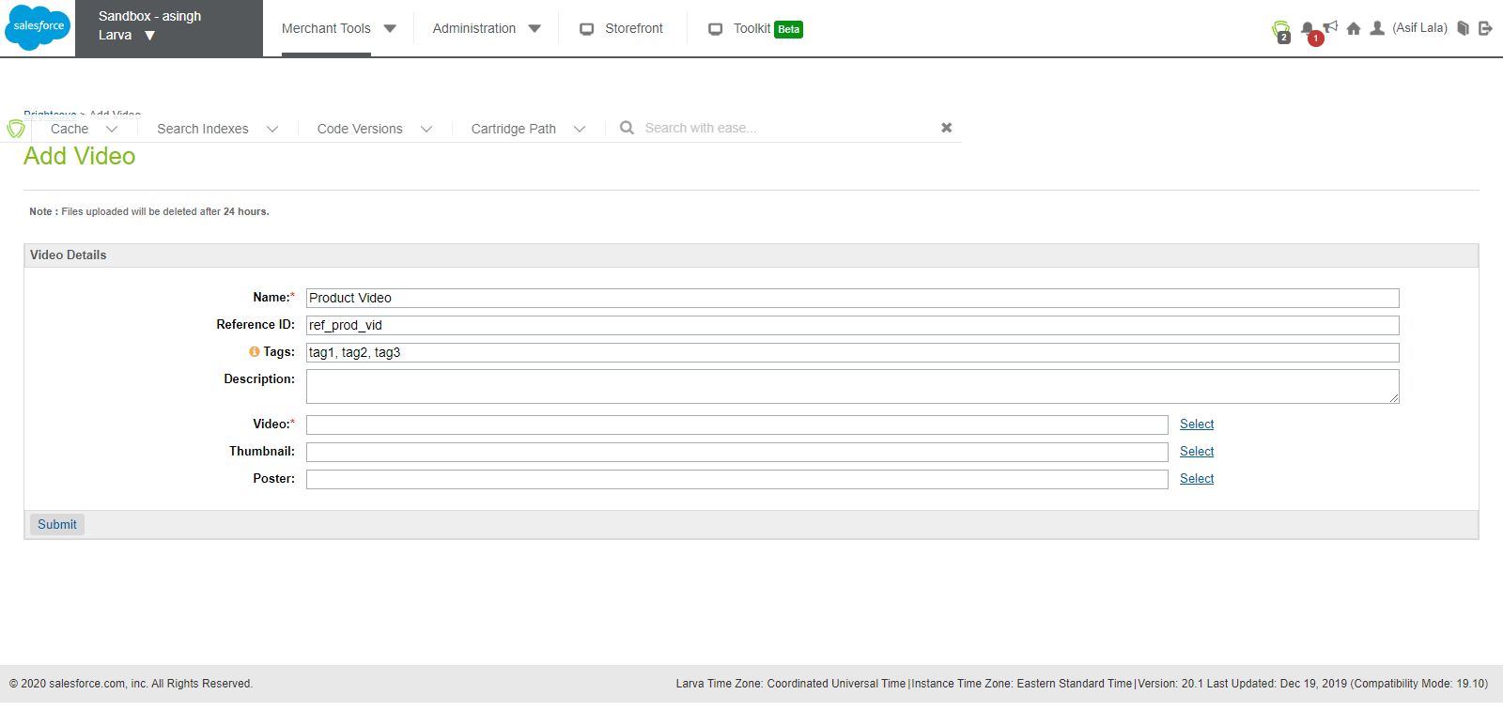

1. Click on **Select** option as shown below, it will give you a pop-up to select the video from list of files.

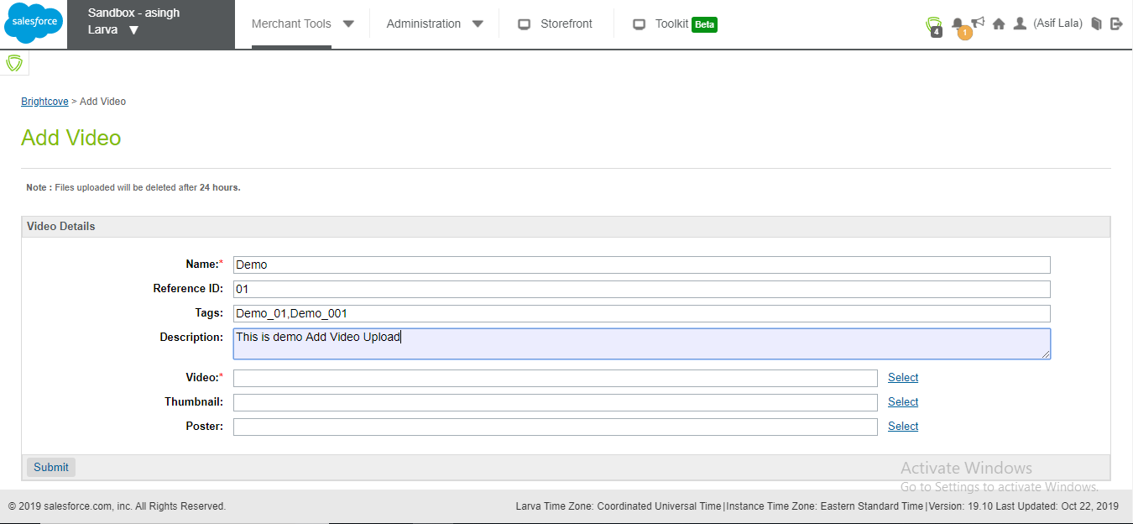

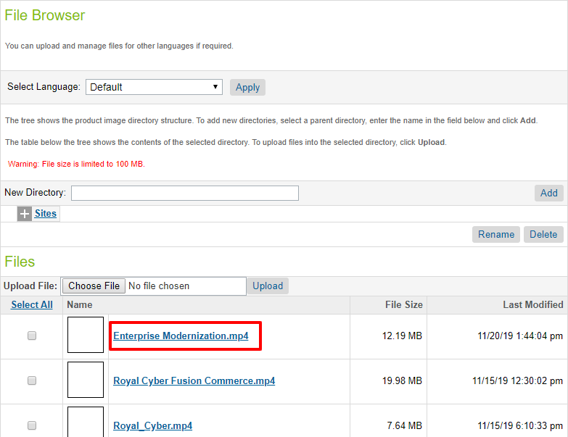

1. Likewise, if you like, you can select file for **Poster** and the **Thumbnail,** but these fields are optional.
2. Now click the “Submit” button to upload the desired video on to the Brightcove Server

1. “Video file ingested Successfully” message is shown as below.

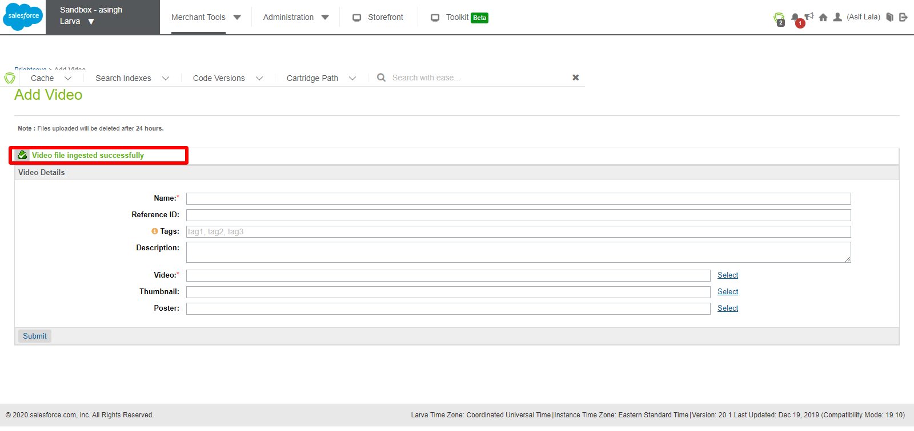

1. Login to the Brightcove Server and check if video file is uploaded successfully.

For example: (shown below)

Name- **Demo**

Reference ID- **01**

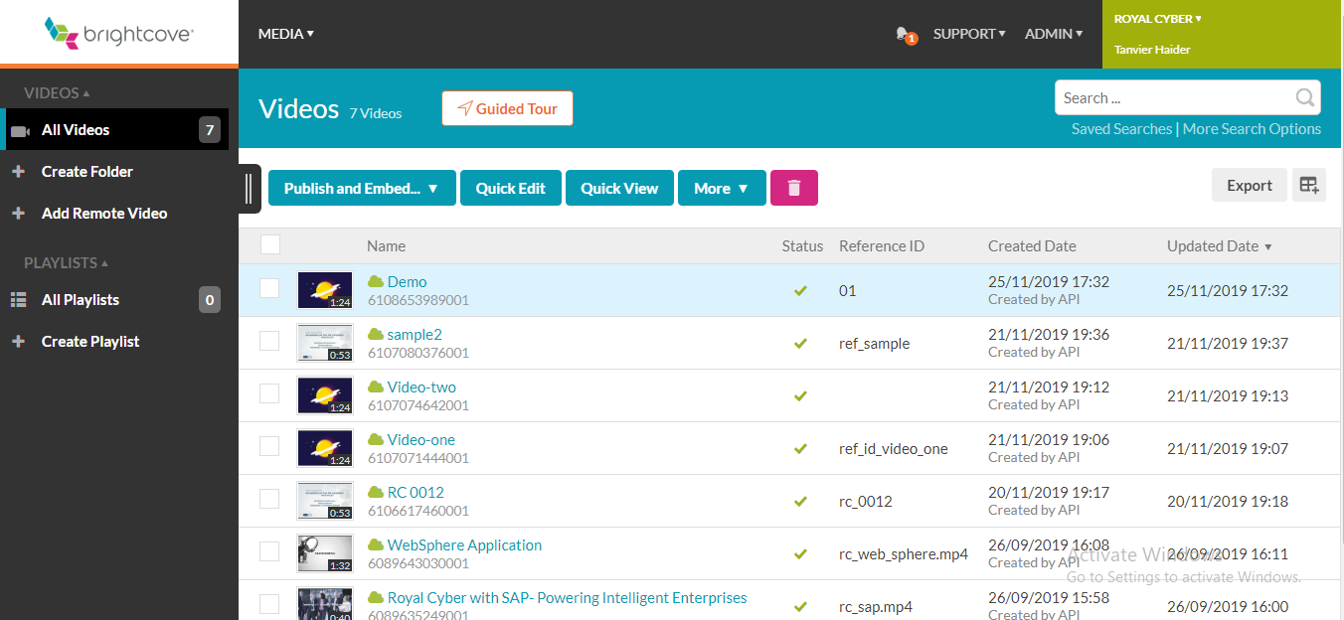

## 1.2 How to assign a video to a product in SFCC

“Assign Video” Module provides the functionality to assign a video, that has already been uploaded to the Brightcove server, to a product, as in the product catalog, in SFCC. Here are the steps:

1. Login to the SFCC Business Manager with your valid credentials.
2. Select Merchant Tools from the top-level BM menu and then navigate to Brightcove section as shown in below screenshot.



1. Under Brightcove option Select “Assign Video”.

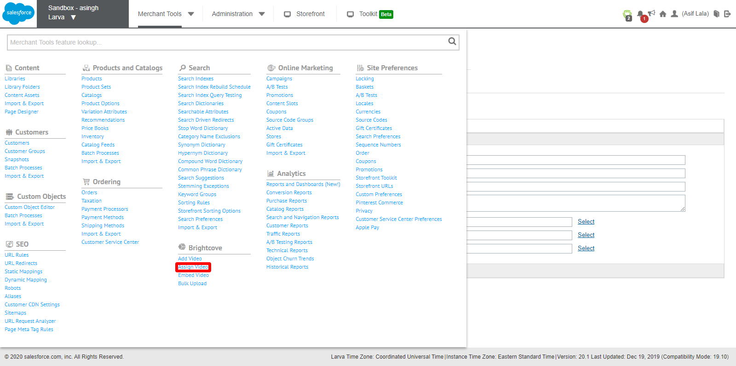

Under Assign video page, as shown in the screenshot below, videos can be assigned or un-assigned to any of the product for the catalog.

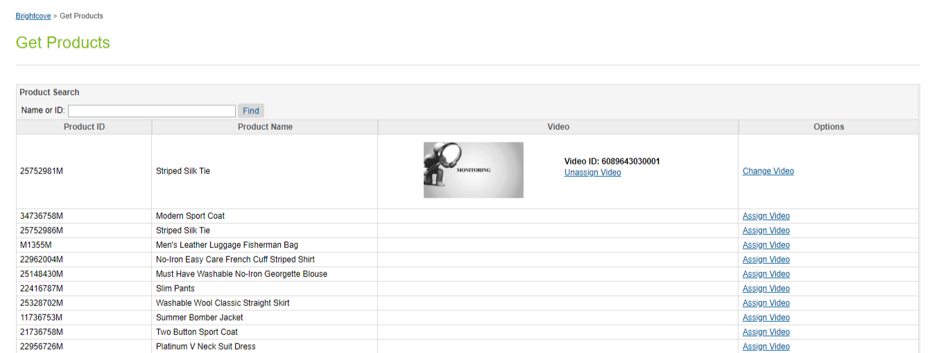

1. For example, consider the Product i.e. ‘**Modern Sport Coat**’ with ProductID ‘**34736758M**’

Now you can assign the video to this Product as mentioned below by clicking the “Assign video” link/button.

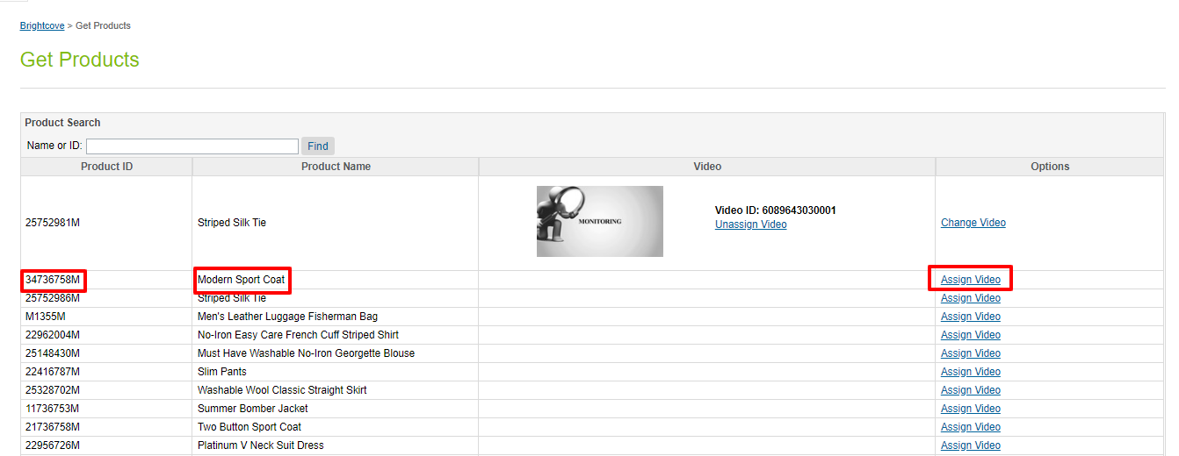

1. After Clicking the “Assign video” button to the Modern Sport Coat Product, all video files, previously added through add Video functionality is being displayed. Now, any video, as required, can be assigned with a specific product selected.

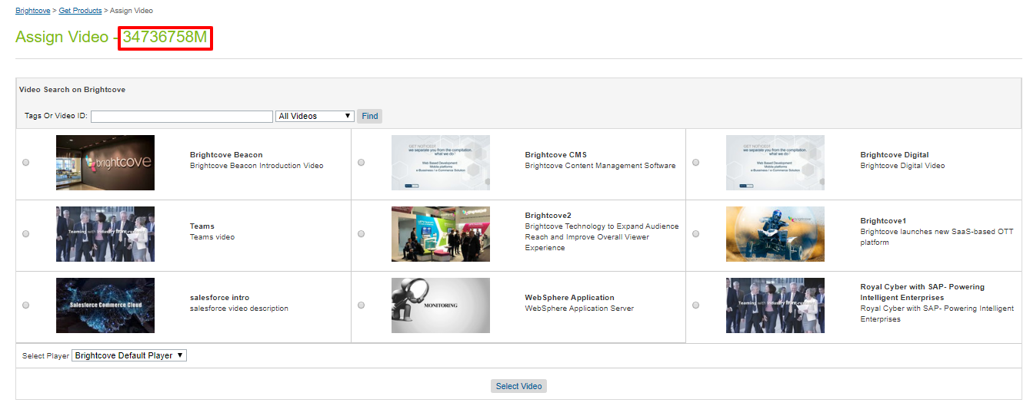

1. Now as Shown above, assign the video by selecting the video and clicking the select button.

‘**Brightcove Beacon’** video is selected as a part of this example.

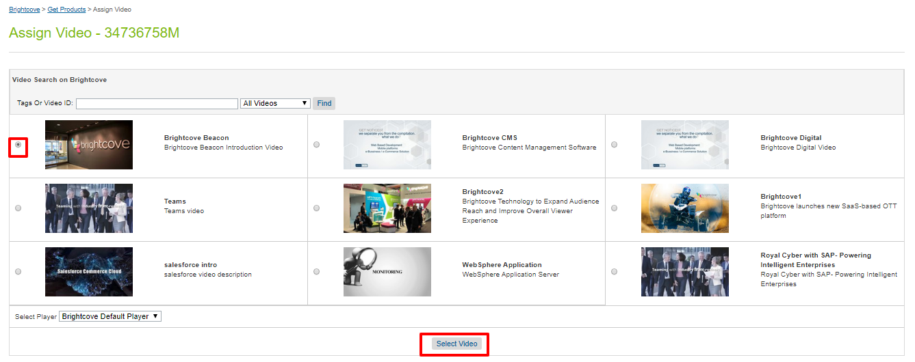

1. After Selecting the video, as shown below, the video is assigned to the specified Product.

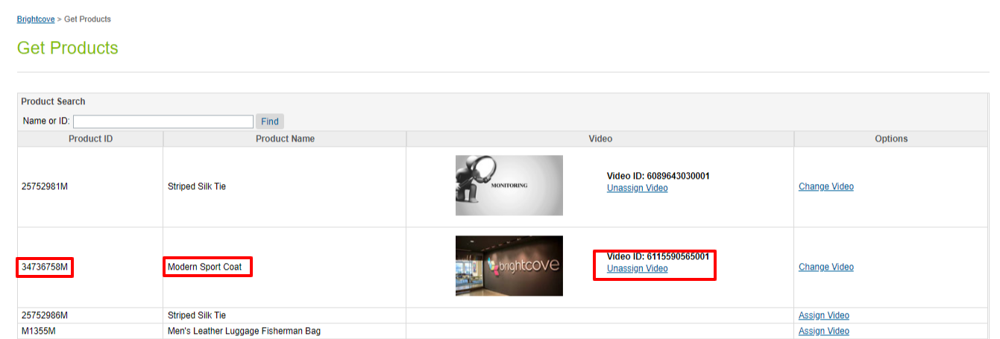

1. Next, go the specific Product, i.e. ‘Modern Sport Coat’, to verify whether the Brightcove video attribute are being assigned to the correct product or not.

Click on Merchant tools-> Products and Catalogs-> Product

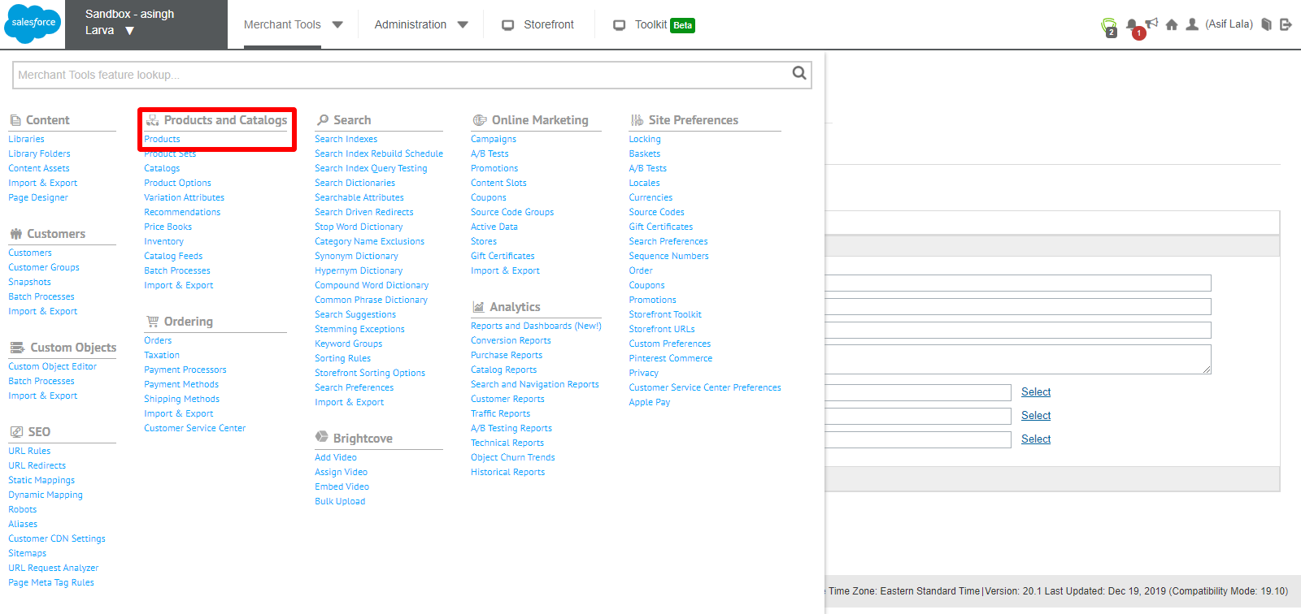

1. Search the product with the ProductID i.e. **34736758M.**

Click on it to open product details and attributes.

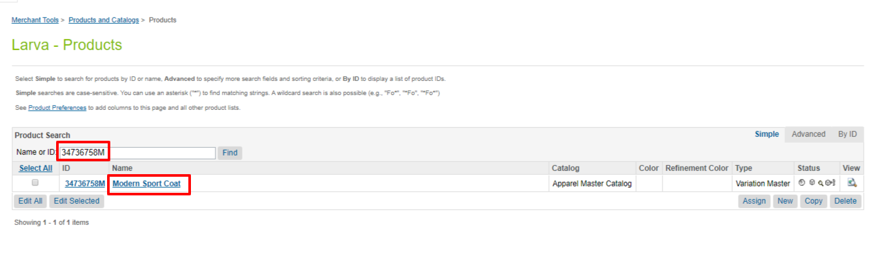

1. As shown below, all video attributes are filled up, once the video is assigned.

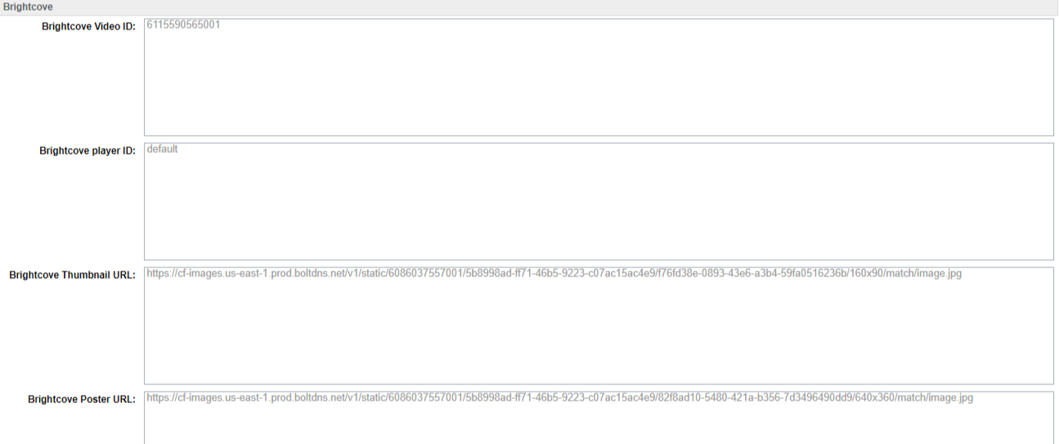

1. Similarly, a video file can be un-assigned or decoupled from a product in SFCC, by clicking the “Un-assign video” button located under the video file. Once this step is completed, video attributes for the product get set to blank (as shown below).

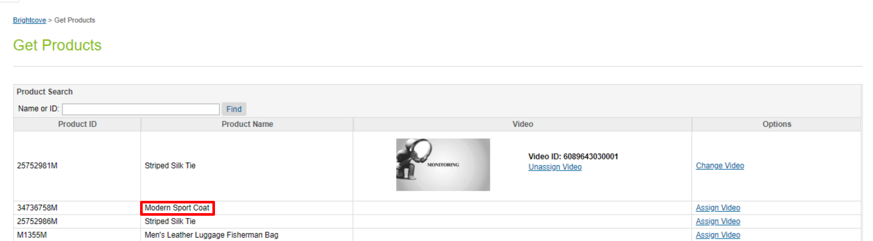

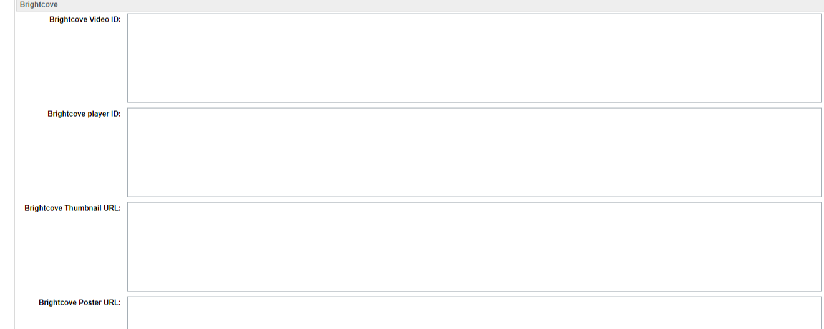

## 1.3 How to embed a video in a content slot:

The “Embed Video” functionality enables an SFCC business user with embedding iFrame or Java script code for any video or media file residing on the Brightcove server, in any of the content slots, to render that video on any of the store pages. Here are the steps:

1. Login to the SFCC Business Manager with your valid credentials.
2. Select Merchant Tools from the top-level BM menu and then navigate to Brightcove section as shown in below screenshot.



1. Click on Embed Video Option.

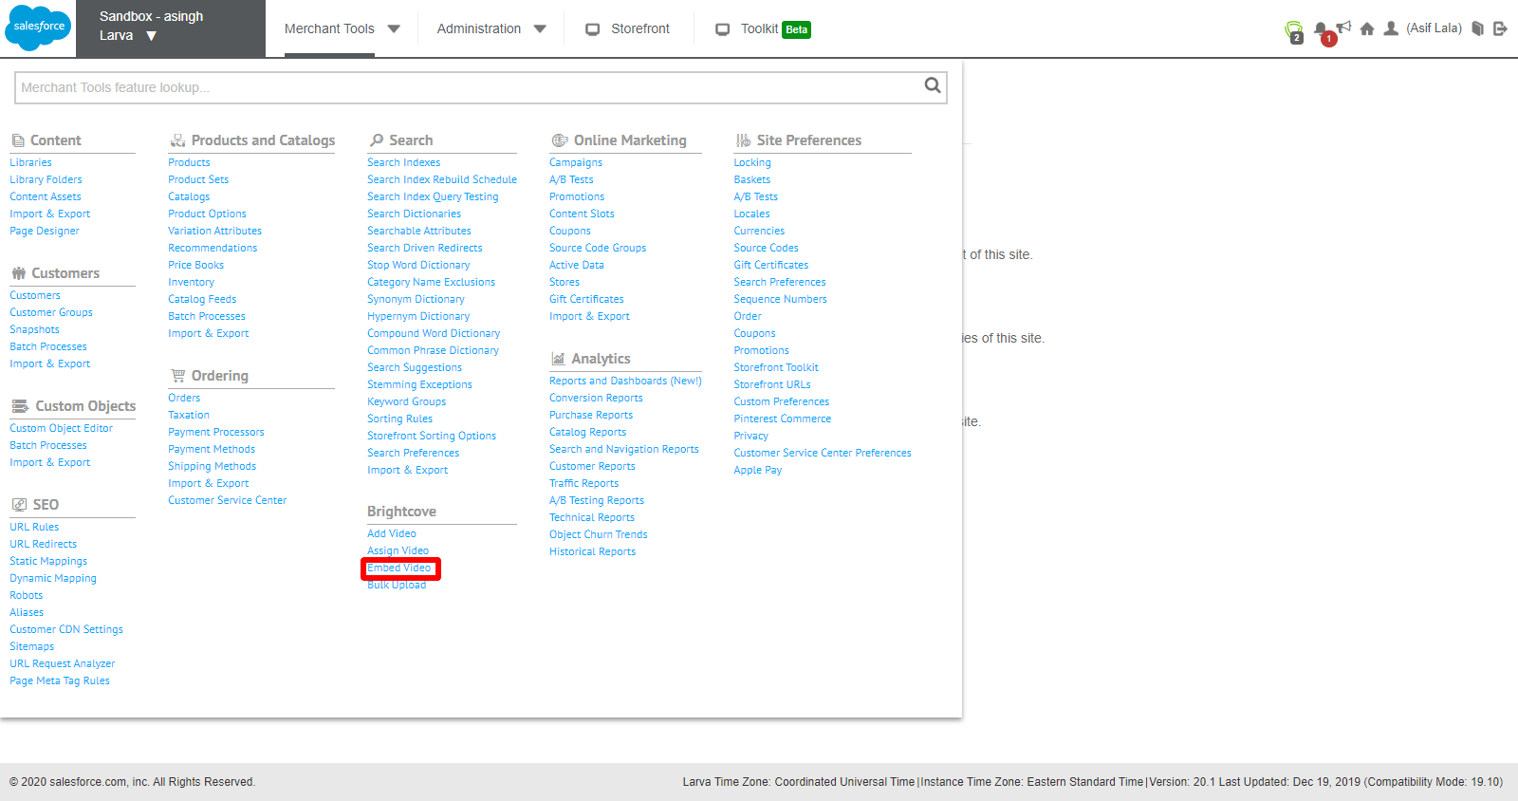

1. Under Embed Video page, search the video files with ‘**tags**’ or ‘**videoID**’ as provided, when you added the Video, through Add Video functionality.

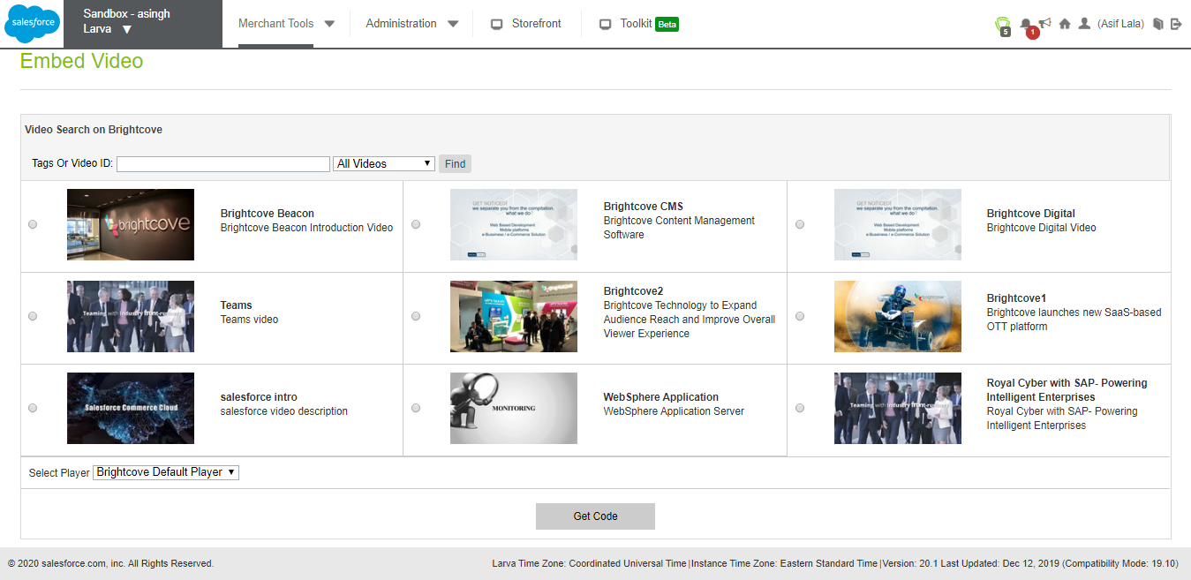

(a)- Search by ‘**Tags**’:

For e.g. search by tag i.e. “Teams” as shown below. PlayerID is the default PlayerID i.e. Brightcove default player. Select the dropdown as shown below.

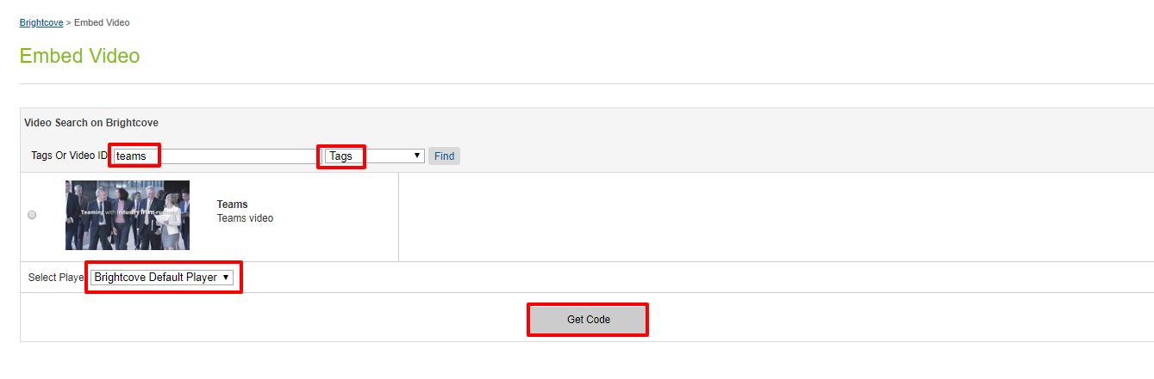

1. Now click on “Get Code” button, a popup window will open up, which provides the iframe and the Java Script code for the video to be embed, in any of the content slot as required. Copy to clipboard and paste it.

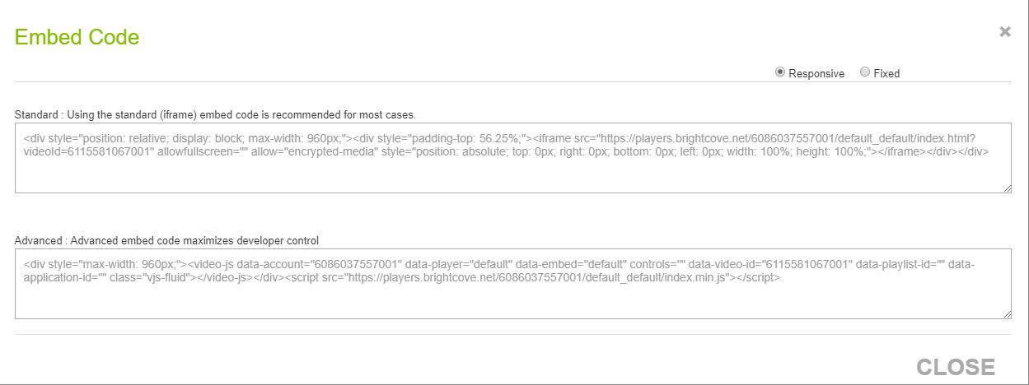

(b)- Similarly search by ‘**videoID**’ and follow the steps as above afterwards.

For e.g. search by tag i.e. “**6113671820001**” as shown below. PlayerID is the default PlayerID i.e. Brightcove default player. Select the dropdown as shown below.

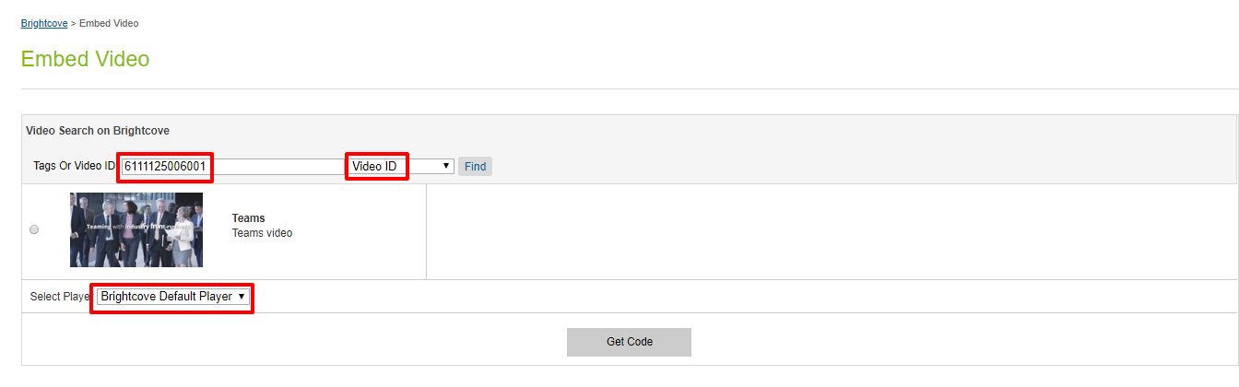

1. Now follow the same process as followed in search by video ‘tags’.

See get code section i.e.

click on “Get Code” button, a popup window will open up which provides the iframe or the Java script code for embedding video files in the content slot. Click “Copy to clipboard” and paste it where needed.

## 1.4 PDP Rendering:

“PDP Rendering” Module provides the functionality to render video corresponding to the product on the PDP page. This would require mapping of a product with video id existing in the local SFCC catalog database. Here are the steps.

1. Repeat steps (1-7) from “Assign Video” section (1.2).
2. Go to storefront and search for the assigned product (as in the screenshot below). The video is assigned to a product and to all variants of the product.

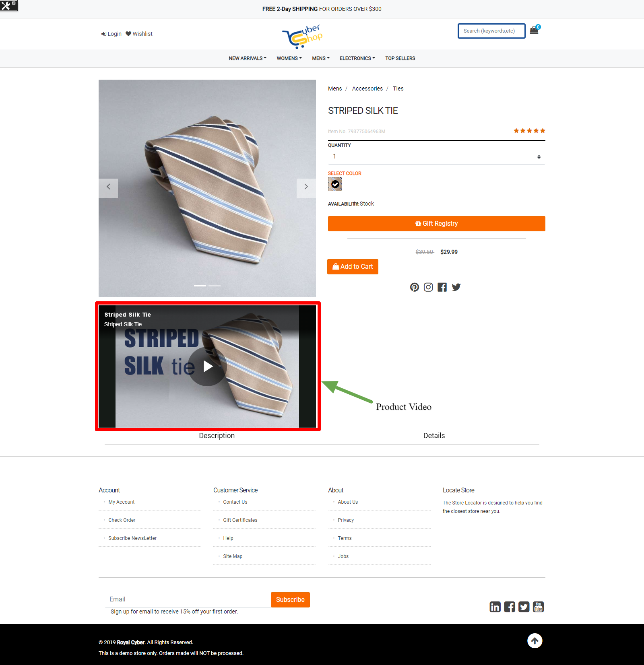

## 1.5 Bulk-Upload:

“Bulk-Upload” Module provides the functionality to upload more than one file to the Brightcove server in one go. Business users can use a csv file containing details of files to be uploaded (name of file, location of the file etc.) during this process. Here are the steps.

1. Login to the SFCC Business Manager with your valid credentials.
2. Select Merchant Tools from the top-level BM menu and then navigate to the Brightcove section as shown in below screenshot.

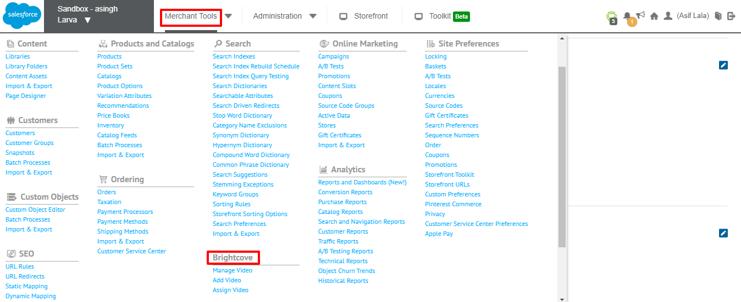

1. Under Brightcove section Select/click “Bulk Upload”.

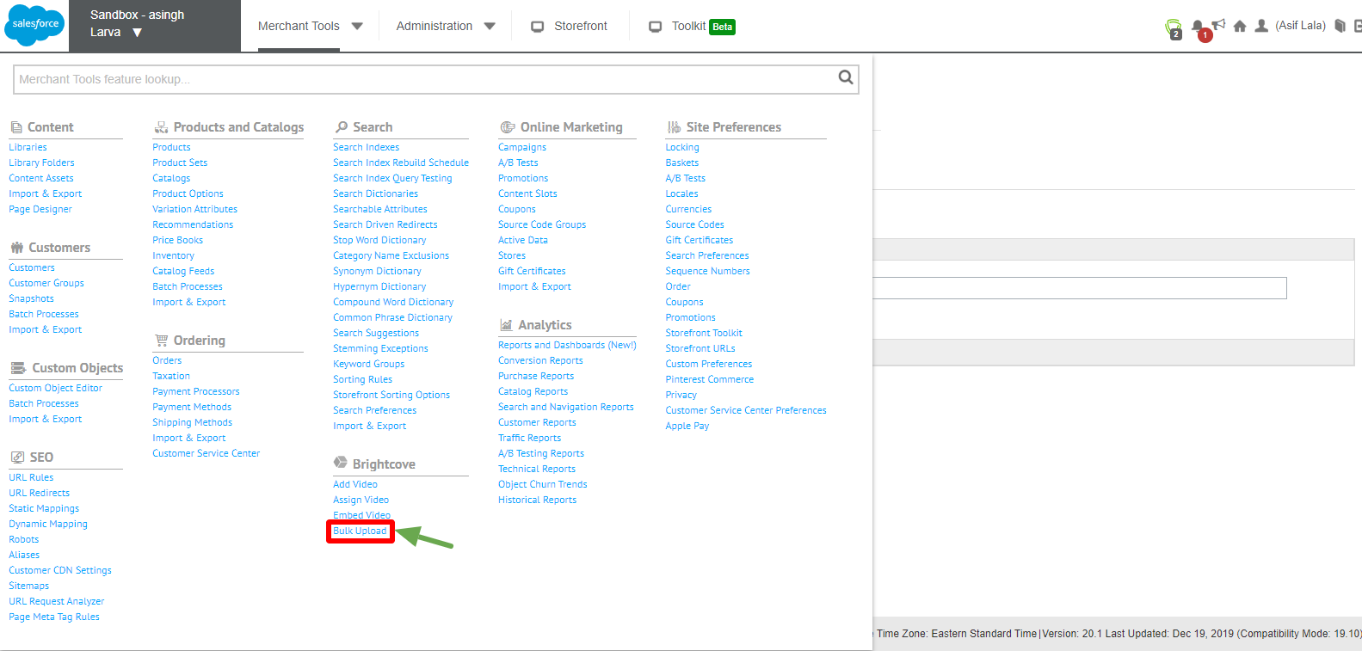

1. Select CSV file (that contains files to be uploaded details) and process it by clicking the “submit” button.
2. You can verify success of the upload process by logging to the Brightcove server.

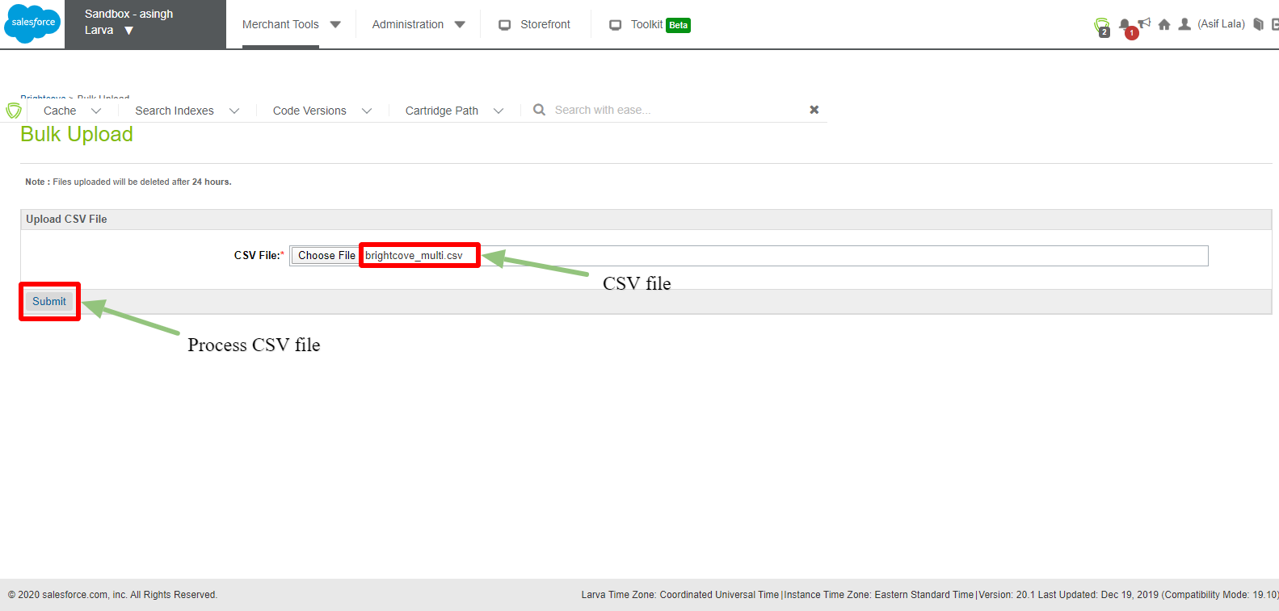

# Troubleshooting common issues